Project Title and Team Members

**Calorie Counter Website**

**LABID-6**

**Team Members:**

1. **Maryam Albakhiet Class ID-2**
2. **Nikita goyal Class ID-10**

**Motivation:**

We are consuming a lot of unhealthy food and to keep track of our health we need to know what type of food we are consuming each day. How many calories we are intake. So, our Calorie Counter Website will help the users to keep track of their daily calories intake. Hopefully by that, they can watch their weight and live healthier lives with our website.

**Significance**

* Daily Calories Counting.
* Food lists.
* Meals planning.
* Calories target depends on the user's weight and height.

**Features:**

* Login page
* Signup page
* Dashboard which will display the users calorie chart
* Search bar where user can put any item of food to check the calorie
* A home page
* Users account page
* Contact us page
* Suggestions for meal planning
* A page where people can post only fitness related videos
* A people can find a nearby gym and see the reviews

**Demo screens from project**

**Calorie counter page:**

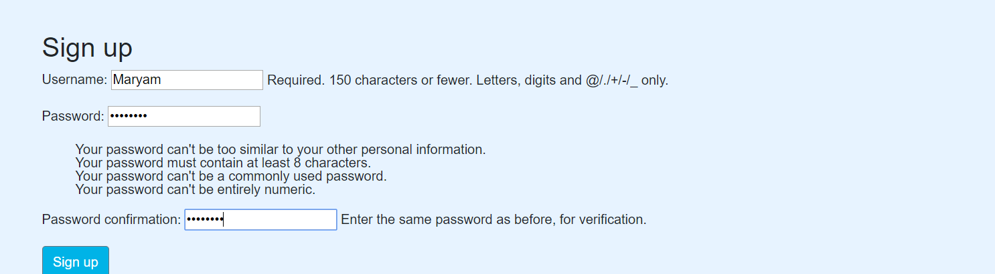

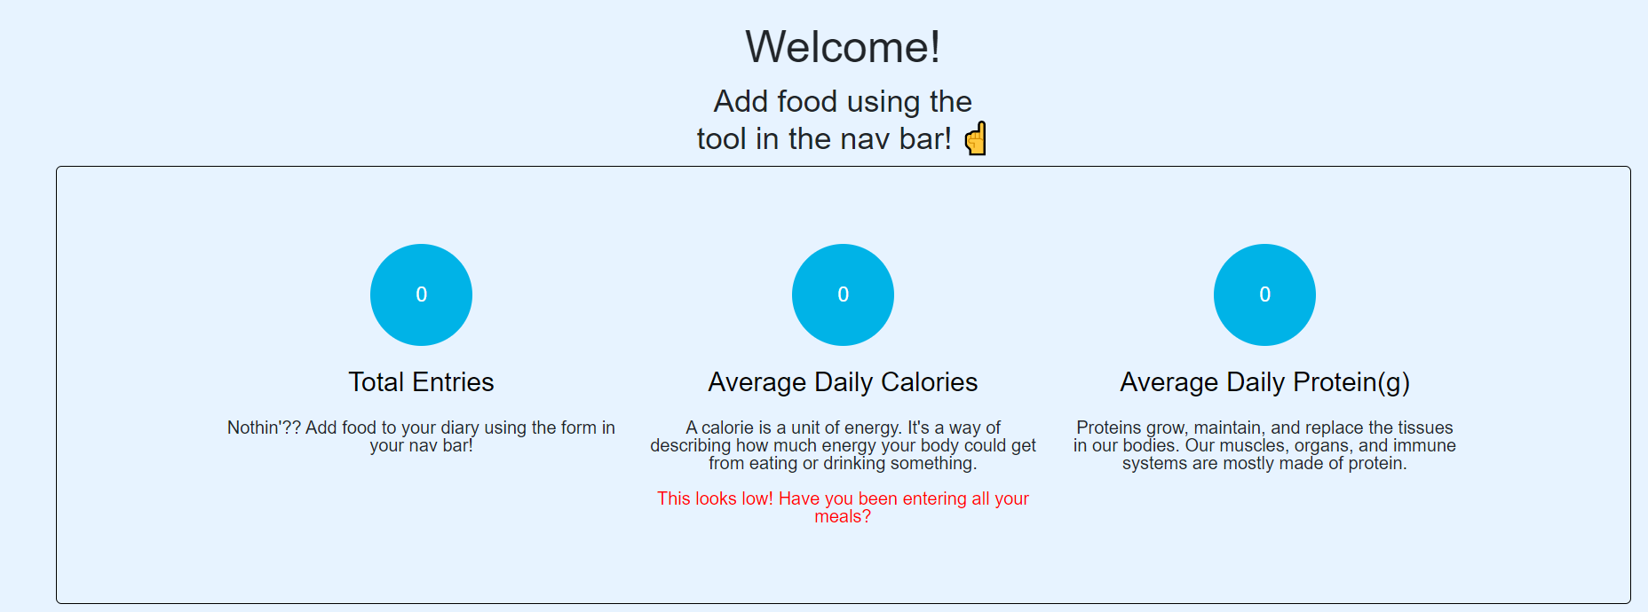

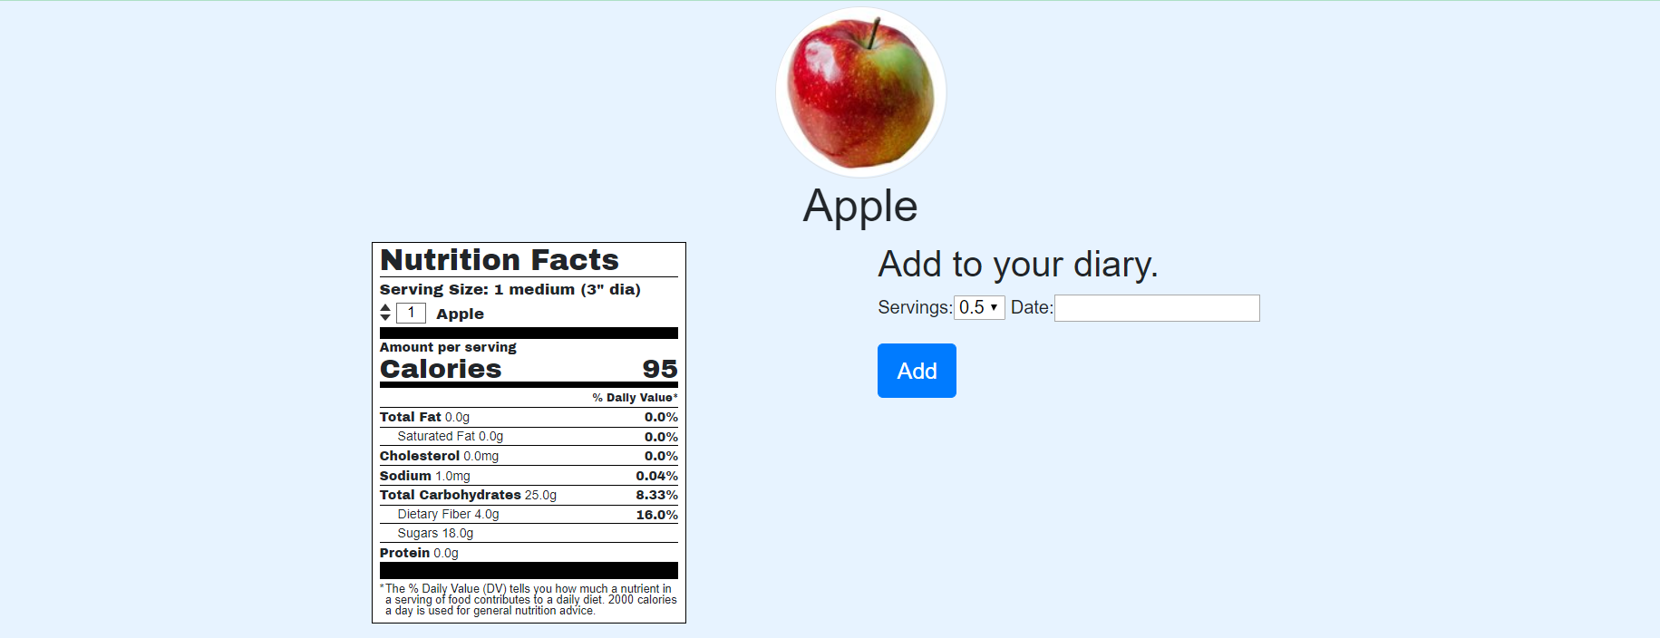

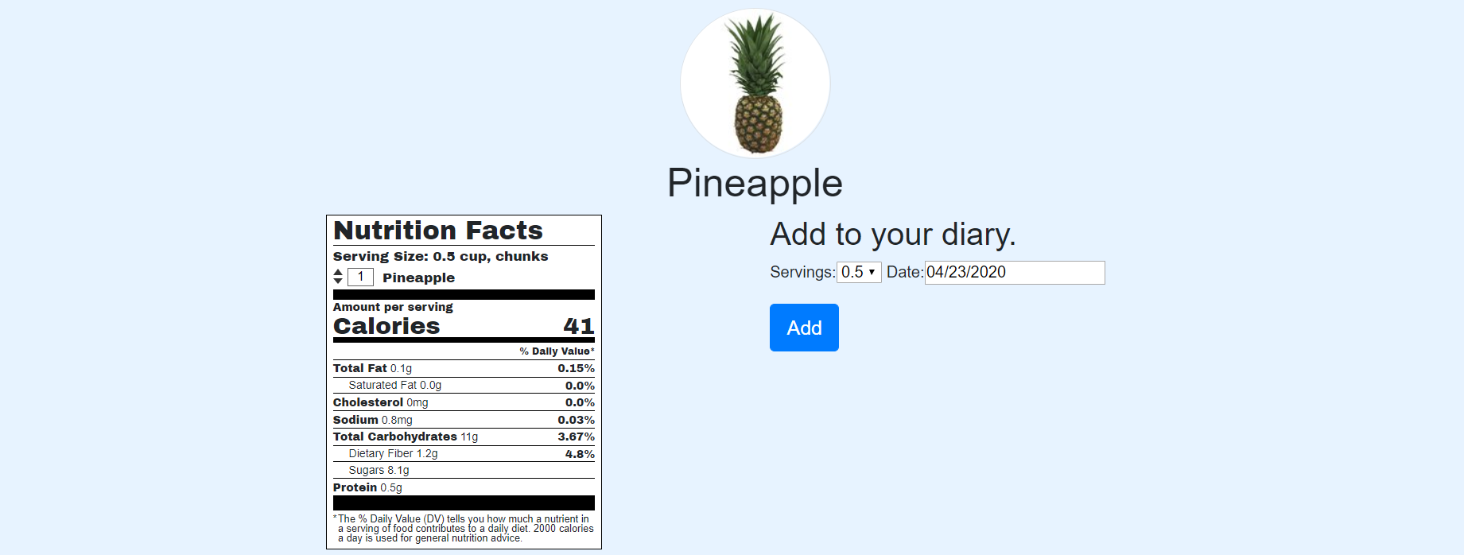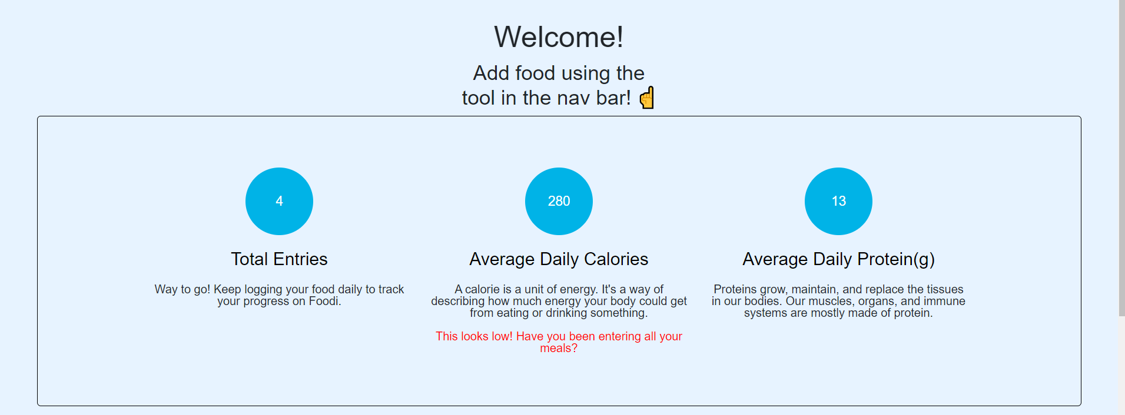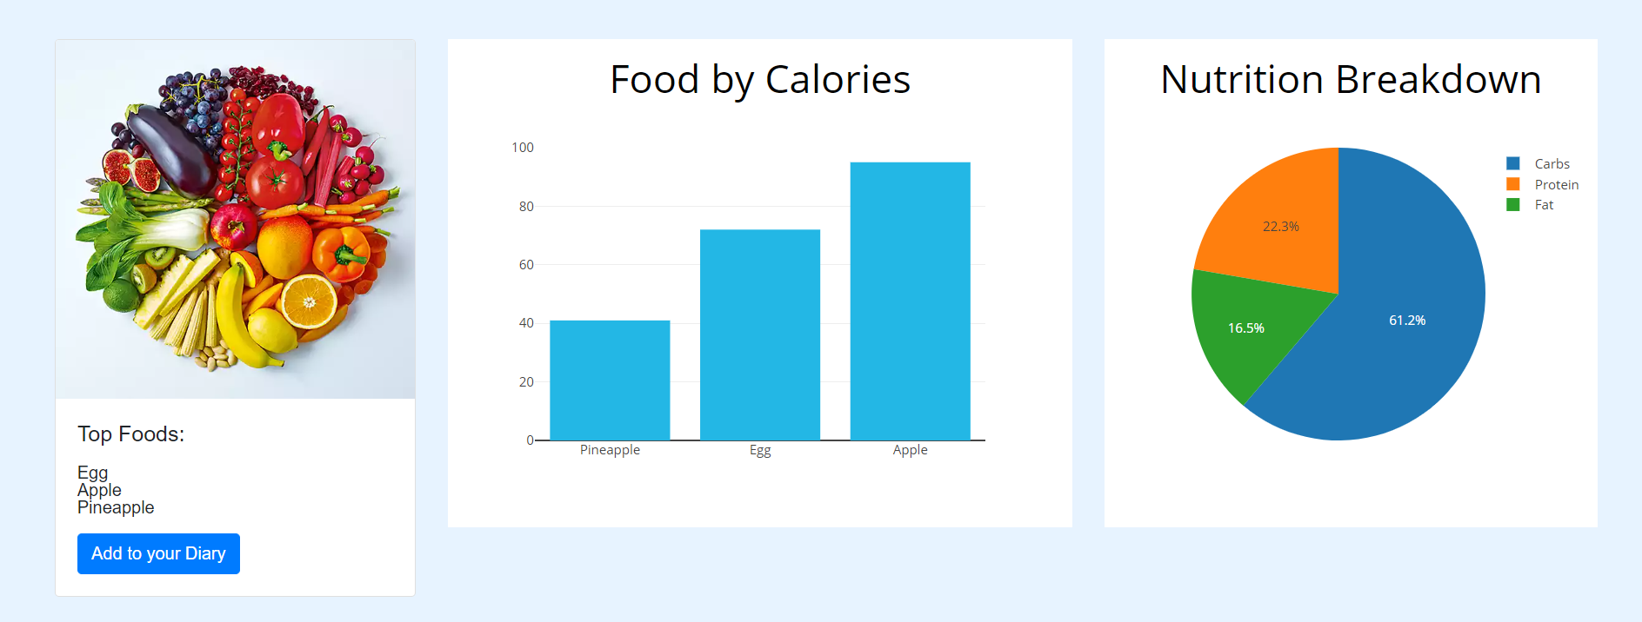

**Improvement from the proposal stage**

We improvised our idea:

1. To make it different, we have thought about adding a page in which users can post any type of fitness video.
2. Users can search a nearest gym near their house
3. More features can be added as we evolve in the project

**GitHub link for your project**

[**https://github.com/Nikii1118/Web-Programming-/tree/master/Project/Project-Increment1**](https://github.com/Nikii1118/Web-Programming-/tree/master/Project/Project-Increment1)

**Work sharing/Module sharing between teammates**

We evenly divided the project pages to build between me and my teammate and then we will collaborate the whole project together. Since, we are only two members in a team. We will try to do our best to achieve our goals for this project.

**References:**

[**https://www.webmd.com/diet/healthtool-food-calorie-counter**](https://www.webmd.com/diet/healthtool-food-calorie-counter)

[**https://play.google.com/store/apps/details?id=com.myfitnesspal.android&hl=en_US**](https://play.google.com/store/apps/details?id=com.myfitnesspal.android&hl=en_US)

[**https://www.my-calorie-counter.com/**](https://www.my-calorie-counter.com/)

[**https://www.calculator.net/calorie-calculator.html**](https://www.calculator.net/calorie-calculator.html)

[**https://www.cancer.org/healthy/eat-healthy-get-active/take-control-your-weight/calorie-counter-calculator.html**](https://www.cancer.org/healthy/eat-healthy-get-active/take-control-your-weight/calorie-counter-calculator.html)

[**https://www.myfitnesspal.com/**](https://www.myfitnesspal.com/)